3GPP TSG RAN WG1 Meeting #83 R1-156690
Anaheim, USA, 15th - 22th November 2015

Source: Intel Corporation
Title: On enhancements to resource pool configuration for V2V communication
Agenda item: 6.2.8.1.1
Document for: Discussion and Decision

Introduction
At the TSG RAN1 Meeting #82, the study on LTE based V2X services [1] was started. The system level evaluation assumptions were agreed and captured in [2]. In this contribution, we continue analysis of the different resource allocation aspects [3]-[4] focusing on enhancements of resource pool configuration. In particular, we mainly discuss the resource allocation principles for PC5-based V2V communication that were captured for further analysis at the previous RAN1 WG meeting #82bis:
- Resource pool
  - The concept of resource pool is introduced at least for the purpose of study.
  - Resource pool is a set of time/frequency resources where PC5 transmission may occur. Note that Rel-12 D2D communication mode 1 uses all the time/frequency resources as data pool.
  - FFS whether Rel-12 resource pool configuration is reused for PC5-based V2V.
  - FFS the number of resource pools configured for a UE
  - The need for defining multiple resource pools should be justified.
  - FFS whether the number of SA pools can be different from the number of data pools and, if can, FFS whether multiple SA pools can be associated with the same data pool.
- Scheduling assignment
  - Each data transmission is scheduled by an SA.
  - FFS whether SA and Data are not transmitted on separate physical channels:
    - In case of separate channels, study whether SA pool and data pool are orthogonal or can overlap.
  - FFS whether SA and data from a single transmitter can be transmitted in the same subframe
  - Study the number of transmissions of a given TB
  - Study the number of transmissions of a given SA
  - FFS whether a single SA may schedule multiple TBs
  - FFS whether the time/frequency resources of a given SA is independent of the time/frequency resources of the associated data
- Enhanced resource randomization
  - Example is increasing the number of time resource patterns.
Our views on other V2V communication aspects are provided in our companion contributions [6]-[13].

Resource Pool Considerations
On resource pool
The concept of resource pools introduced in LTE Rel.12 for sidelink operation can be also used for V2V resource allocation at least for the purpose of proper V2X resource indication for vehicular transmission/reception. The latter is needed when V2X is shared with Uu carrier and only a portion of spectrum resources is allocated for vehicular services. Another benefit to use resource pools is to differentiate control and data channels so that receiver can process control resources and decode the subsequent data. The resource pool concept is also beneficial in terms of the multi-TTI processing so that UE can process and combine several transmissions carrying the same information. The combining requires definition of resource pool at least for the control channels, so that receiver UE knows where the initial transmission and retransmissions may take place.
The enhancements to the LTE Rel.12 sidelink resource allocation may provide additional performance gains for V2V communication. In particular, the following principles may be evaluated to see the incremental gain:
- Boundary-less operation. The existing PSCCH/PSSCH channels are based on the physical resource pool periodicity. The PSCCH/PSSCH pools of preconfigured duration are periodically repeated in time. The allocation of single pool results in common pool boundaries across all UEs, that may negatively affect performance due to reduced randomization capabilities and therefore it may be desirable to smooth pool boundaries, e.g. by introducing UE specific transmission cycles, configuring multiple pools and/or removing strict physical linkage between PSCCH and PSSCH resource pools.
- Reduced waiting time to access sidelink control resources. The current waiting time for access to sidelink control resources is constrained by the SCI period if single pool is configured. In order to reduce waiting time, and satisfy latency requirements, the FDM allocation of multiple PSCCH/PSSCH pools may be configured. Alternatively, the TDM allocation between PSCCH/PSSCH with the reduced periodicity of control channel resource occurrence may be used.
- UE-specific transmission intervals/cycles. In LTE Rel.12, the data transmission intervals are common across UEs operating in the same pool. Each sidelink transmission starts and ends within a given PSCCH/PSSCH pool period. This behavior may limit randomization capabilities across UEs and may result in congested PSCCH. The congestion in PSCCH may be reduced if SCI signaling points to the data spanning several SCI periods/transmission cycles.
Observation 1
- The boundary-less operation with reduced waiting time for access to sidelink control resources and UE specific transmission cycles may provide additional randomization capabilities and improve V2V performance.
On Amount of Resource Pools
In general, the single pool can be sufficient for V2V communication, unless support of priority mechanisms with preferential access to certain resources or geo-based transmission schemes are introduced. On the other hand, having single pool seems artificial restriction given that the Rel.13 sidelink already support multiple pools. In LTE Rel.13, it is also possible to associate multiple control pools with the same data pool by proper configuration (e.g. the configuration of two or more PSCCH pools with the identical PSSCH configuration may be used for that purpose). The usage of multiple pools may reduce latency and improve randomization if properly configured.
Observation 2
- Multiple pools can be beneficial if priority handling and/or geo-based transmission are supported for V2V communication.
- Support of multiple pools may improve randomization properties and reduce latency subject to proper resource pool configuration.

Considerations on PSCCH/PSSCH Multiplexing
The separate control (PSCCH) and data (PSSCH) channels should be considered as a default option for V2V communication unless significant performance gains are demonstrated. The PSCCH should be more robust and reliable comparing to data since the decoding of PSCCH may be beneficial for congestion control and ISIC types of receivers, if implemented. The multiplexing of PSCCH and PSSCH in the same subframe is not desirable from the single UE perspective and is subject to SC-FDM constraint, however it may be considered from system level perspective by means of configuration, although benefits of this option require further studies. The encoding of the control and data in the same channel may reduce robustness of PSCCH reception and further complicate the RX processing. In addition, the control information may suffer from the additional link budget loss, if multiplexed with data in the same subframe.
Observation 3
- Multiplexing of PSCCH and PSSCH in one channel reduces PSCCH link budget which may have negative impact on system performance and imposes additional receiver complexity.

Discussion on Pool Allocation
In this section, we analyze different resource pool configurations that may provide additional randomization. In particular, we consider the following options (see Figure 1):
Option 1: TDM Resource Allocation (Single Pool – Baseline). This is a baseline resource pool allocation option that was evaluated in [6] and can be considered as a reference Rel.12 sidelink performance. The PSCCH and PSSCH resources are time multiplexed. The following parameters were used for evaluation of this option:
- PSCCH/PSSCH 8/32; T-RPT (N = 8, k = 2, 4; random start time); 15 kHz; 1 ms; QPSK; 12 PRBs (190 bytes) / 24 PRBs (300 bytes); 4 TTIs.
- PSCCH/PSSCH 8/32; T-RPT (N = 8, k = 2, 4; random start time); 15 kHz; 1 ms; 16QAM; 6 PRBs (190 bytes) / 12 PRBs (300 bytes); 4 TTIs.
Option 2: FDM Resource Allocation (Multiple Pools). This option may be implemented using multiple resource pool configurations. The PSCCH and PSSCH resources from different pools are multiplexed in frequency. The PSSCH pools overlap in time by either 25%, 50%, 75%, emulating boundary-less operation principle. The following parameters were used for evaluation:
- PSCCH/PSSCH 8/32; T-RPT (N = 8, k = 2, 4, random start time); 15 kHz; 1 ms; QPSK; 10 PRBs (190 bytes) / 20 PRBs (300 bytes); 4 TTIs; four PSCCH/PSSCH pools with different time offsets.
- PSCCH/PSSCH 8/32; T-RPT (N = 8, k = 2, 4, random start time); 15 kHz; 1 ms; 16QAM; 5 PRBs (190 bytes) / 10 PRBs (300 bytes); 4 TTIs; four PSCCH/PSSCH pools with different time offsets.
Option 3: TDM Resource Allocation (Multiple Pools). This option may be implemented using multiple resource pool configurations. The PSCCH and PSSCH resources are multiplexed in time. The two PSSCH pools overlap in time by 50% reducing pool boundary effect on PSSCH transmission. The following parameters were used for evaluation of this option:
- PSCCH/PSSCH 4/32; T-RPT (N = 8, k = 2, 4; random start time); 15 kHz; 1 ms; QPSK; 12 PRBs (190 bytes) / 24 PRBs (300 bytes); 4 TTIs; two PSCCH/PSSCH pools with different time offsets.
- PSCCH/PSSCH 4/32; T-RPT (N = 8, k = 2, 4; random start time); 15 kHz; 1 ms; 16QAM; 6 PRBs (190 bytes) / 12 PRBs (300 bytes); 4 TTIs, (multiple of 4); two PSCCH/PSSCH pools with different time offsets.
Option 4: TDM Resource Allocation (UE specific transmission cycles). This option does not assume explicit pool resource configurations for PSCCH and PSSCH rather than simply indicates resource available for control and data transmissions. The UE can access any allocated PSCCH and PSSCH resources. The UE transmission cycle for PSCCH and PSSCH is predefined in terms of maximum transmission duration. Once UE has packet for transmission, it randomly selects (m_{PSCCH} out of n_{PSCCH}) subframes for PSCCH transmission and (m_{PSSCH} out of n_{PSSCH}) subframes for PSSCH transmission over predefined time interval (UE transmission cycle). This option completely removes PSCCH/PSSCH pool boundaries by utilizing UE specific transmission cycles in terms of PSCCH/PSSCH transmission start/end time. The PSCCH and PSSCH resources are time multiplexed. The following parameters were used for evaluation of this option:
- PSCCH (UE specific transmission cycle: 2 random TTIs out of 8 upcoming PSCCH subframes, 50 PRBs); PSSCH (UE specific transmission cycle, 4 TTIs, T-RPT (N = 8, k = 2, 4; random start time); QPSK 12 PRBs (190 bytes) / 24 PRBs (300 bytes).
The Option 4 can be also evaluated for the case when PSCCH and PSSCH resources overlap in time and frequency. However, it may have negative impact on control channels and thus requires additional analysis.
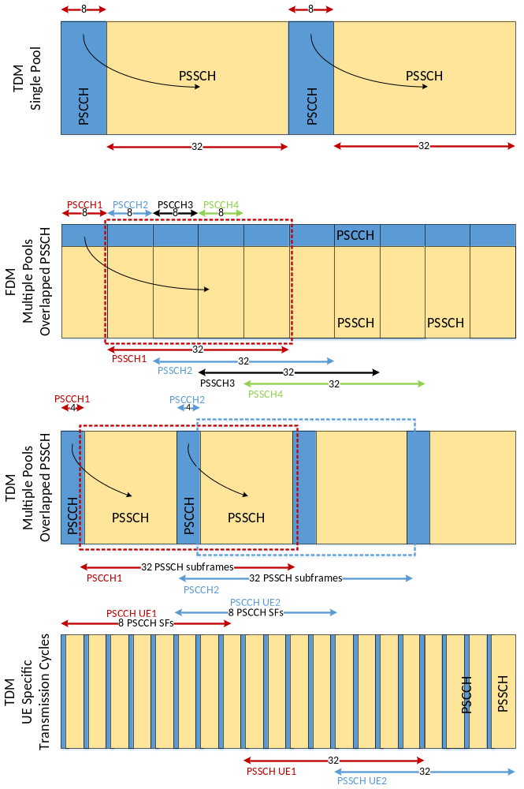
Figure 1: Resource Pool Allocation Options.
The system level evaluation results of the described above resource allocation options are shown in Figure 2 and Figure 3 for PRR CDF and average PRR respectively.
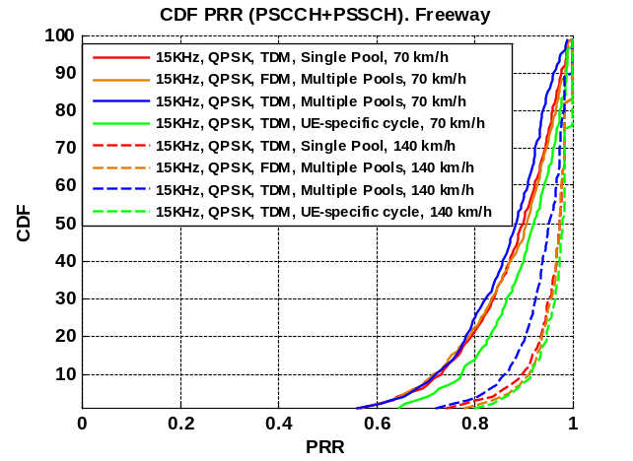 | 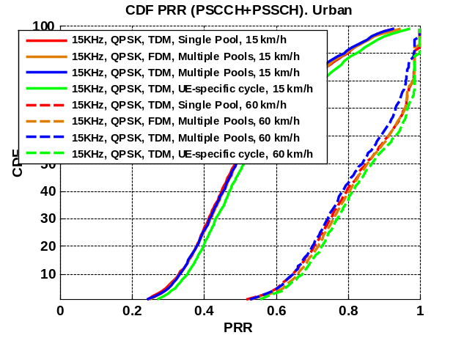
Figure 2: Evaluation of different pool configurations (PRR CDF).
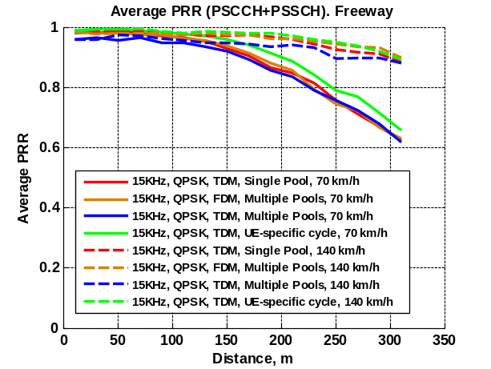 | 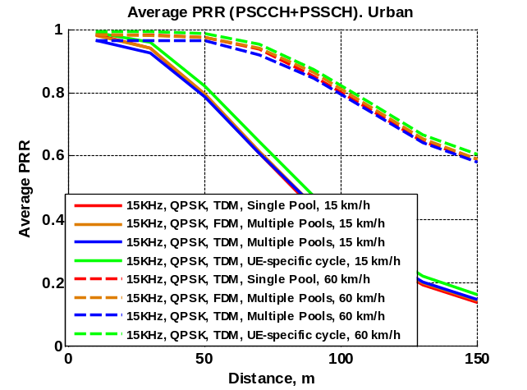
Figure 3: Evaluation of different pool configurations (Average PRR).

Based on the presented analysis, we have the following set of observations:
Observation 4
- All considered resource allocation options show similar PRR performance.
- The resource allocation utilizing random UE-specific access to PSCCH resources and UE specific transmission cycles within PSSCH resources demonstrates slightly better performance in all scenarios.
- The FDM resource allocation with multiple pools shows similar performance as baseline TDM configuration with single PSCCH/PSSCH pool.
- The TDM resource allocation with two pools shows slightly worse performance than TDM with single resource pool which can be explained by reduced randomization within PSCCH due to reduced number of PSCCH subframes.

Enhanced T-RPT Randomization
In this section, we analyze additional randomization of T-RPT patterns used for V2V transmission. In particular, instead of using the Rel.12 T-RPT framework with randomized start time, we assume that any subframe combination within PSSCH pool can be used for transmission (i.e. m_{PSSCH} out of n_{PSSCH} rule is applied within all PSSCH subframes). The results are provided for resource allocation Option 1 as described in the previous section. The analysis is presented in Figure 4 and Figure 5 for PRR CDF and average PRR respectively.
- PSCCH/PSSCH 8 SFs/32 SFs; 15 kHz; 40ms period; T-RPT Baseline (N = 8, k = 2, 4; random start time - baseline); QPSK; 12 PRBs (190 bytes) / 24 PRBs (300 bytes); 4 TTIs;
- PSCCH/PSSCH 8 SFs/32 SFs; 15 kHz; 40ms period; T-RPT Random (nchoosek(32,4) – fully random); QPSK; 12 PRBs (190 bytes) / 24 PRBs (300 bytes); 4 TTIs.
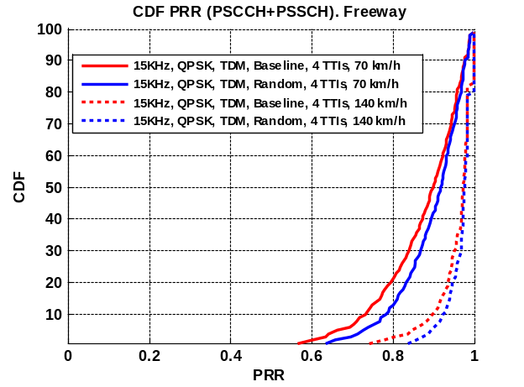 | 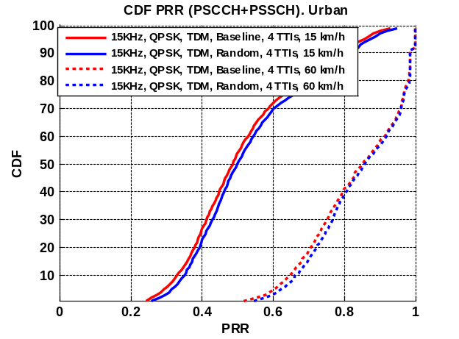
Figure 4: Evaluation of different pool configurations (PRR CDF).

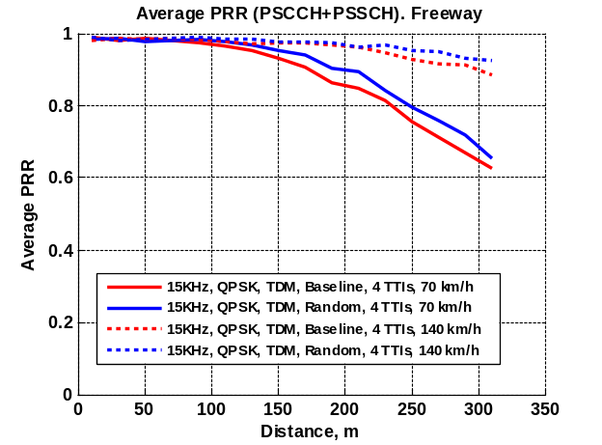 | 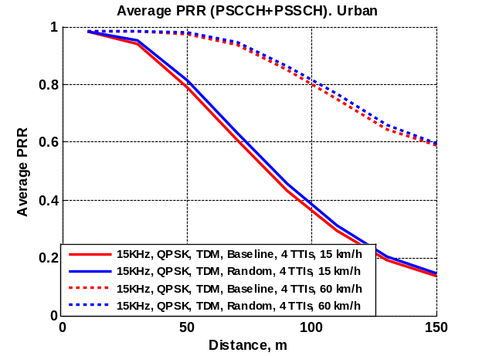
Figure 5: Enhanced T-RPT Randomization (Average PRR).
Observation 5
- Additional T-RPT randomization provides slight PRR performance improvement comparing to the option with random transmission start time within T-RPT.

Semi-Persistent Transmissions
The decoding of both PSCCH and PSSCH may have additional impact on overall PRR performance. In general, the PSCCH has more reliable reception than PSSCH and thus in interference free environment there should be no problem from this perspective. In interference limited scenarios the congestion and impact from in-band and half-duplex effects on PSCCH may have some detrimental effect on overall PRR performance, which needs to be analyzed. This effect (if it is substantial) may be potentially reduced by semi-persistent PSCCH scheduling. The potential benefit of the semi-persistent allocation may come from the reduced congestion in PSCCH. On the other hand the loss of PSCCH may result in failure of several transmitted packets. This tradeoff needs to be further studied.
Observation 6
- The semi-persistent transmission may have a tradeoff in terms of PSCCH congestion and potential loss of multiple PSSCH packets that needs to be further studied.

Conclusions
In this contribution, we evaluated different resource allocation options and their impact on V2V communication performance. We observed that configuration of multiple resource pools may provide slightly improved performance due to improved randomization capabilities. According to our analysis the resource allocation with the UE-specific access to PSCCH resources and UE-specific PSSCH transmission cycle gives additional performance benefits comparing to the option with multiple pools. In addition, the enhanced randomization of T-RPT provides slight incremental gain relative to the option with random start time within T-RPT. We also notice, that semi-persistent PSCCH transmission needs further study in terms of PSCCH performance benefits and the risk to not receive the series of semi-persistently transmitted packets.

References
- RP-151109, “New SI proposal: Feasibility Study on LTE-based V2X Services”; LG Electronics, CATT, Vodafone, Huawei; Malmö, Sweden, June 15 - 18, 2015.
- R1-154981, “Updated offline discussion summary on V2X evaluation assumptions”; LGE; Beijing, China; August 2015.
- R1-155328, “V2V System Level Analysis in Freeway Scenario and Design Enhancements”, Intel Corporation, October 2015
- R1-155329, “V2V System Level Analysis in Urban Scenario and Design Enhancements”, Intel Corporation, October 2015
- 3GPP TR 36.885, “Study on LTE-based V2X Services”
- R1-156687, “Discussion on baseline sidelink performance for V2V communication”, Intel Corp., Nov. 2015
- R1-156688, “On support of geo-based transmission for V2V communication”, Intel Corp., Nov. 2015
- R1-156535, “On benefits of adjusted LTE numerology for V2V communication”, Intel Corp., Nov. 2015
- R1-156536, “System level analysis of V2V design options in Freeway scenario”, Intel Corp., Nov. 2015
- R1-156537, “System level analysis of V2V design options in Urban scenario”, Intel Corp., Nov. 2015
- R1-156689, “Discussion on network control aspects for V2V communication”, Intel Corp., Nov. 2015
- R1-156538, “Demodulation analysis for V2V communication”, Intel Corp., Nov. 2015
- R1-156539, “Synchronization aspects for V2V/V2X communication”, Intel Corp., Nov. 2015

Appendix A: System Level Evaluation Assumptions
In this section, we provide summary of system level simulation assumptions used for V2V evaluation in this document.
Table 1: Summary of system level evaluation assumptions
Parameter | Value
Deployment Scenarios | Freeway road:  Dense: average inter-vehicular distance = 2.5 sec * absolute vehicle speed 70km/h  Sparse: average inter-vehicular distance = 2.5 sec * absolute vehicle speed 140 km/h  Urban:  Dense: average inter-vehicular distance = 2.5 sec * absolute vehicle speed 15kmph  Sparse: average inter-vehicular distance = 2.5 sec * absolute vehicle speed 60 km/h
Channel model | According to the agreed evaluation methodology in [2]
Traffic model | Periodic traffic model according to [2] with randomized initial arrival time  - 190 bytes every 100ms (four consecutive packets)  - 300 bytes every 500ms (every 5th packet)
Bandwidth | 10 MHz / 50 PRBs for PSCCH and PSSCH
Modulation and Transport Block Size | - Packet size - 190 bytes  - QPSK: 12 PRBs (code rate ~ 0.58 per TTI), TBS 1672, MCS 8  - 16QAM: 6 PRBs (code rate ~ 0.54 per TTI), TBS 1544, MCS 14  - Packet size - 300 bytes  - QPSK: 24 PRBs (code rate ~ 0.43 per TTI) , TBS 2472, MCS 6  - 16QAM: 12 PRBs (code rate ~ 0.42 per TTI), TBS 2408, MCS 12
Evaluation modes | Co-channel interference + in-band emission + half-duplex are taken into account  PSCCH & PSSCH;
Number of TTI per PDU | 4 TTIs (baseline)
# DMRSs per subframe | 15 kHz: 4 DMRSs for improved demodulation
Frequency hopping | Enabled

